CANAAN SUITE

Contents

3 | Israel-Palestine Resolution
5 | Simple Judaism Guide
6 | New Palestine Freedom Projects
7 | Gaza Relief
9 | West Bank Made Open
11 | Withdrawal from Lebanon

Policy Brief: Israel-Palestine Resolution
Date: October 18, 2026
Subject: Proposed Steps for Resolving the Israel-Palestine Conflict

Objective
To outline a structured plan aimed at achieving peace and stability in the Israel-Palestine region through coordinated steps involving leadership changes, citizenship grants, pardons, and eventual democratic elections.

Policy Proposal Summary
- Leadership Transition in Israel:
  - December 1st, 2026: Prime Minister Benjamin Netanyahu will step down from his position.
  - New Role for Netanyahu:
    - Title: “Defender of Israel”
    - Responsibility: Head of the Israel Defense Forces (IDF)
- Citizenship for Palestinian Residents:
  - December 15th, 2026: Granting of Israeli citizenship to all individuals living in Palestine.
- Pardon for Hamas Leadership:
  - December 20th, 2026: General amnesty for the leadership of Hamas.
- Direct Democratic Elections:
  - January 3rd, 2026: Holding of direct presidential elections to establish a unified government of Israel on the land of Palestine.

Detailed Steps and Rationale
- Leadership Transition:
  - This step aims to create a new dynamic in the Israeli leadership, with Netanyahu taking on a pivotal security role to ensure continuity and stability within the IDF, while allowing for new political leadership to emerge.
- Granting Citizenship:
  - Providing Israeli citizenship to Palestinian residents is necessary to maintain a state. This step seeks to eliminate statelessness and provide equal rights and protections under the law.
- Pardon for Hamas Leadership:
  - The pardon aims to facilitate reconciliation and reduce hostilities by offering an olive branch to Hamas leaders. This step is crucial for ensuring a transition.

- Direct Democratic Elections:
  - Conducting direct presidential elections is the final step in legitimizing the new political structure and giving all citizens a voice in their governance. The President will serve a three year term and appoint a Prime Minister. The Prime Minister will form the government of Israel.

The proposed steps include a new dynamic in Israeli leadership, granting citizenship to eliminate statelessness, pardoning Hamas leadership for reconciliation, and holding democratic elections to legitimize the new political structure.

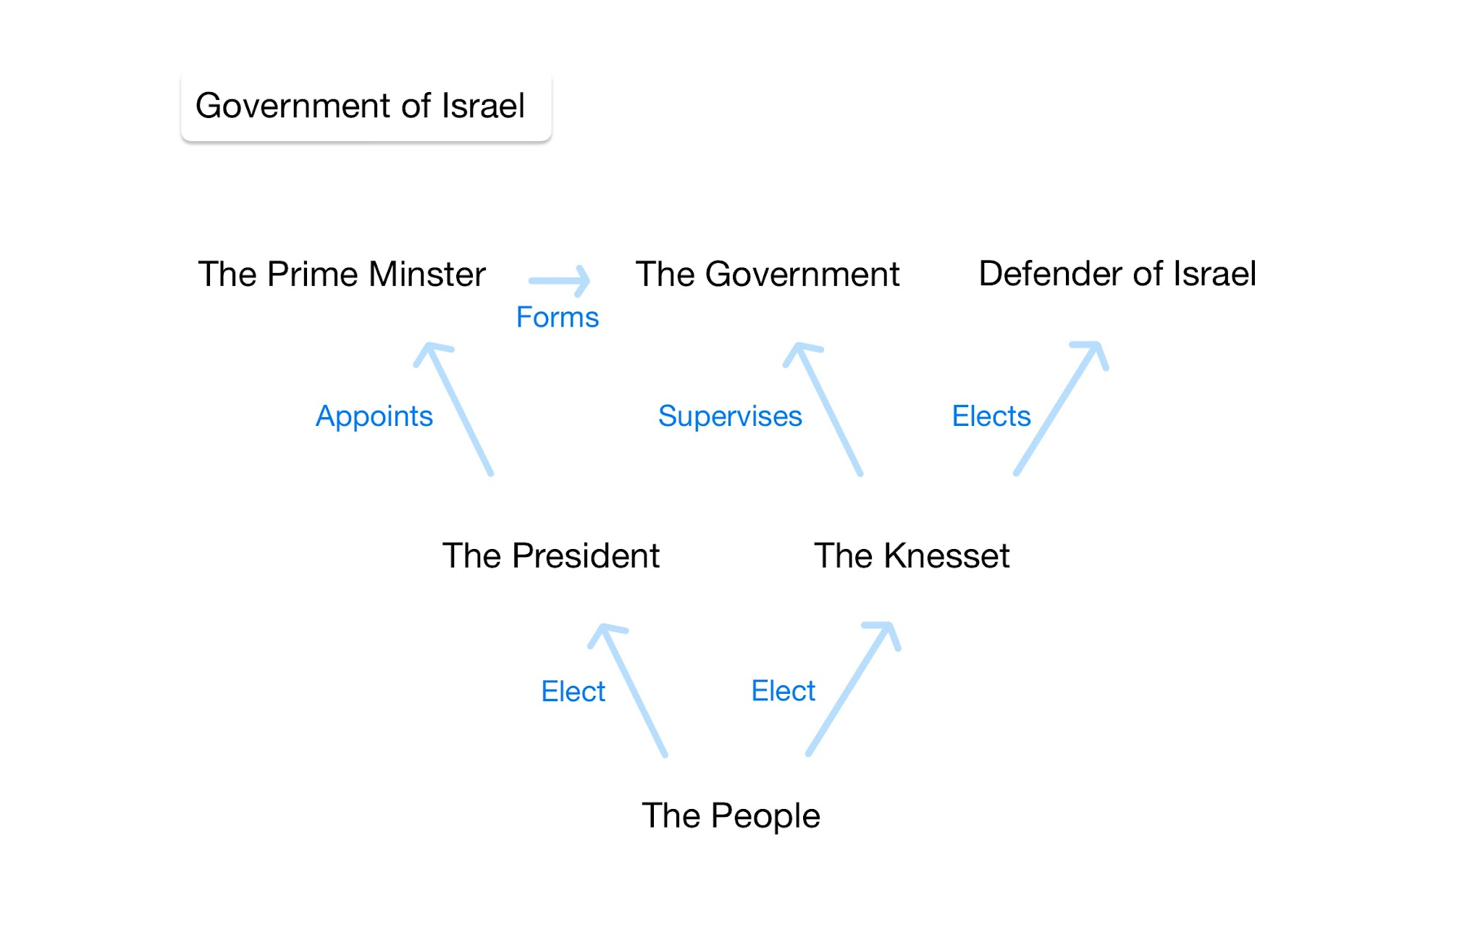
Government Framework
Timeline
- December 1st, 2026 - Benjamin Netanyahu transitions to new role as head of the IDF.
- December 15th, 2026 - Citizenship granted to residents of Palestine.
- December 20th, 2026 - Hamas leadership pardoned.
- January 3rd, 2026 - Presidential elections held.

Conclusion
This policy proposal outlines a comprehensive and phased approach to resolving the Israel-Palestine conflict. By addressing leadership roles, human rights concerns, and democratic governance, the plan aims to foster a sustainable and peaceful resolution for all parties involved.

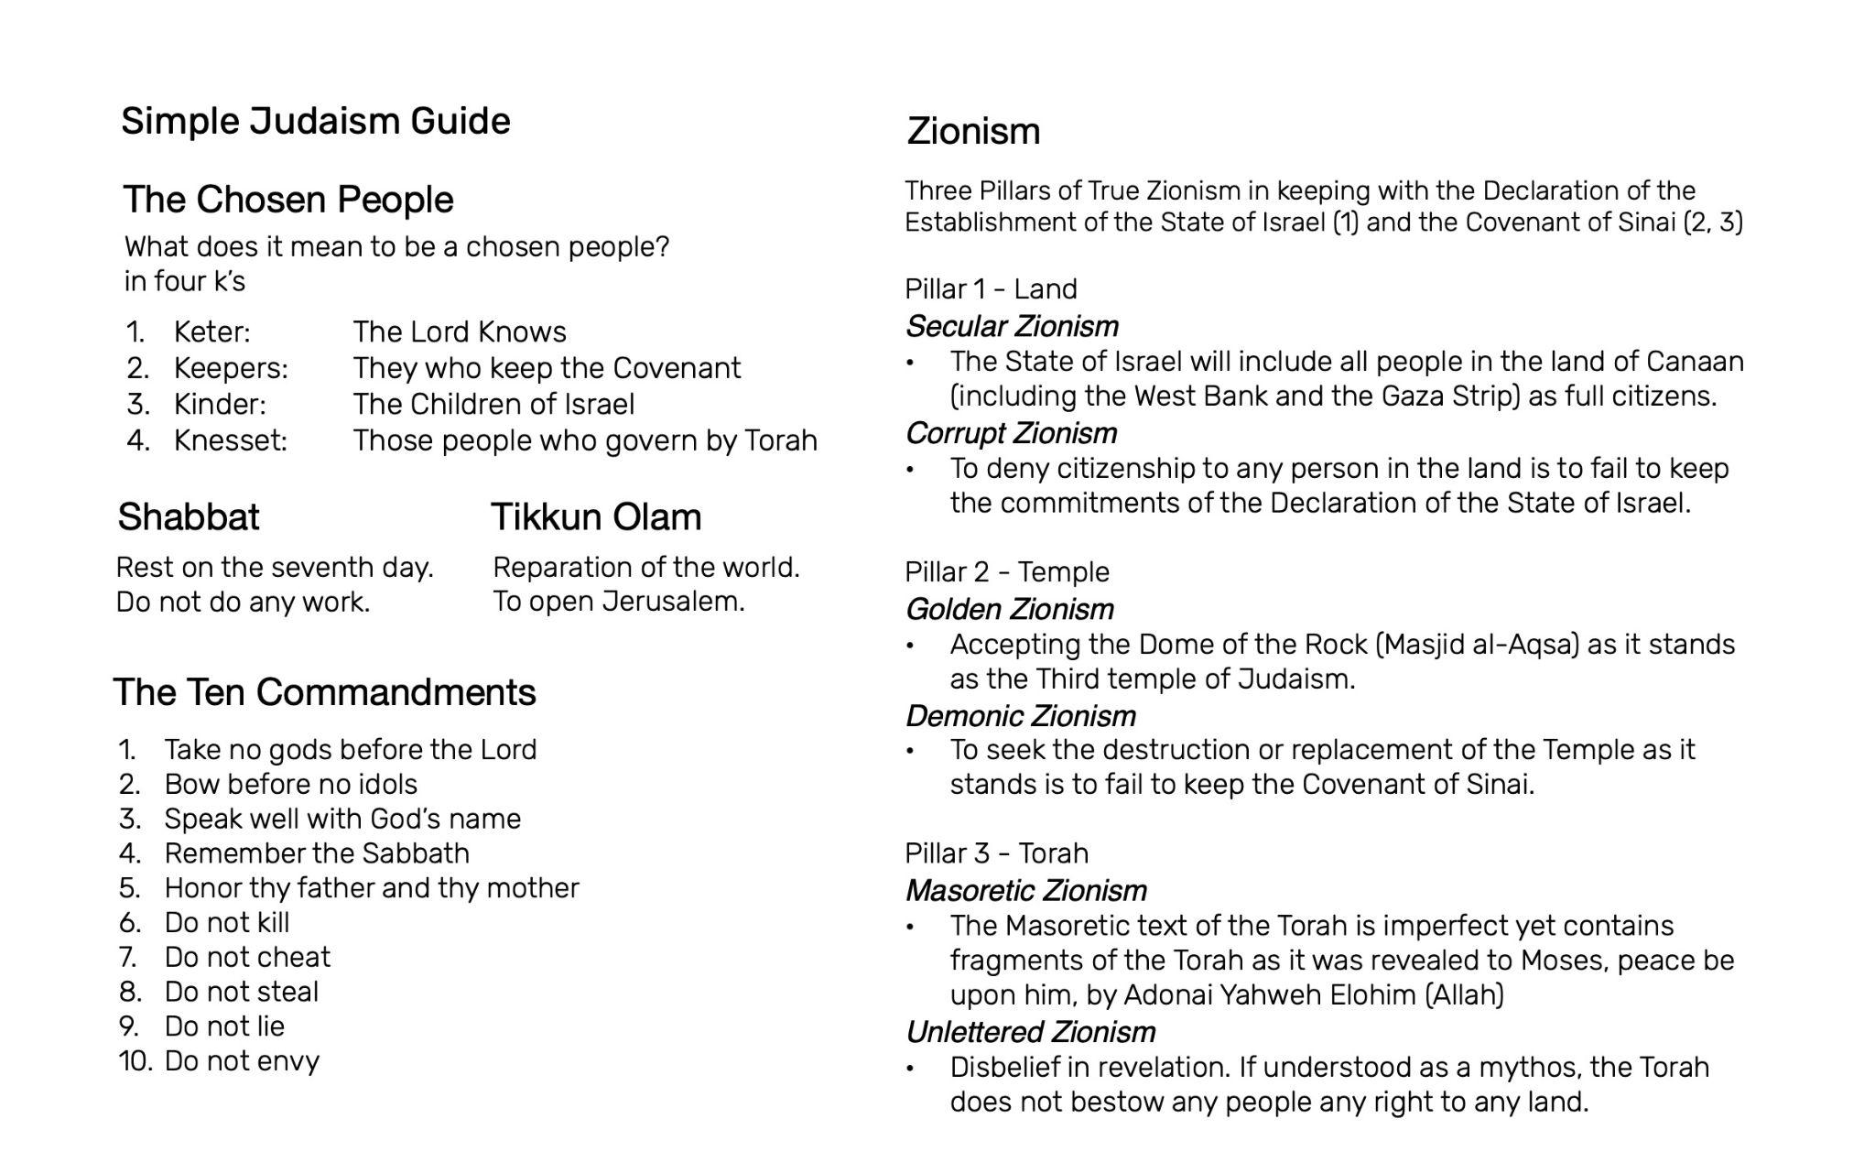

New Palestine Freedom Projects

Ot Reki Do Mora:
- Rejects two state framing: IDF has control of West Bank and Gaza Strip borders
- Advocates full citizenship rights for people in occupied territories

AllahuAkbar:
- Believe the Return to Zion is written in the Quran, Surah Al-Isra 17:104
- Believes secular government for a state of Israel fulfills Surah Al-Baqarah 2:256 (la ikraha fi Dīn)

Ain Sof Aur
- Kabbalistic Trojan horse
- Inside the walls

Contact: NewPalestineFreedomProjects@proton.me

Policy Brief: Gaza Relief
Date: October 18, 2026
Subject: Proposition to provide comprehensive humanitarian relief to people in the Gaza strip.

Objective
To outline a structured plan aimed at achieving full access to basic needs for the people living in the Gaza strip, through citizenship grants, barrier demolition, and rapid housing infrastructure development.

Policy Proposal Summary
- Citizenship for Gaza strip residents:
  - December 15th, 2026: All people in the Gaza Strip granted citizenship to the state of Israel.
- Demolition of Gaza strip barriers
  - Beginning December 15th, 2026, complete by May 15, 2027:
  - All border walls erected around the periphery of the Gaza strip demolished.
- Resettlement Infrastructure with capacity for 1.1 million people:
  - Beginning December 15th, 2026, 550 thousand by February 15th, 2027, complete by May 15, 2027
  - Housing and utilities for 1.1 million people built in southern Israel within 10 miles of the Gaza strip boundary.
  - People in the Gaza strip take priority for resettlement.

Detailed Steps and Rationale
- Citizenship for Gaza strip residents:
  - This step is aligned with granting citizenship to people living in Palestine, the second step of the Israel-Palestine resolution. Necessary to maintain a state. Seeks to eliminate statelessness, and provide equal rights and protections under the law.
- Demolition of Gaza strip barriers:
  - Demolishing periphery barriers on the Gaza Strip border is necessary to enable mobility and access to resettlement. This step is a demonstration of taking a new approach.
- Resettlement Infrastructure with capacity for 1.1 million people:
  - Providing housing and utilities for the people in the Gaza Strip is crucial for ensuring a transition. Housing for 1.1 million people will be constructed in Southern Israel within 10 miles of the Gaza strip boundary. Construction will meet a halfway checkpoint in December and will be completed by March 15th. Access to resettlement is a procedural step in reconciliation and resolution.
The proposed steps include granting citizenship to eliminate statelessness, demolition of Gaza Strip barriers to ensure mobility and access, and development of housing infrastructure to provide resettlement for people in the Gaza Strip.

Timeline
- December 15th, 2026 -
  - Citizenship granted to residents of Palestine.
  - Demolition begins on Gaza strip barriers.
  - Construction begins for resettlement infrastructure.
- February 15th, 2026 -
  - Construction of housing and utilities for 550 thousand people completed.
- May 15th, 2027 -
  - Demolition of Gaza strip barriers completed.
  - Construction of housing and utilities for 1.1 million people completed.

Conclusion
This policy proposal outlines a comprehensive and phased approach to resolving the Gaza Strip crisis. By addressing citizenship, mobility, and housing the plan aims to foster a sustainable and peaceful resolution for all involved.

Policy Brief: West Bank Made Open
Date: October 18, 2026
Subject: Proposition to provide equal access and mobility to the people living in the West Bank.

Objective
To outline a structured plan aimed at achieving full mobility and access to the people living in the West Bank, through citizenship grants and barrier demolition.

Policy Proposal Summary
- Citizenship for West Bank residents:
  - December 15th, 2026: All people in the West Bank granted citizenship to the state of Israel.
- Demolition of West Bank barriers
  - Beginning December 15th, 2026, complete by February 15, 2026:
  - All border walls and fences erected around the periphery of the West Bank demolished.

Detailed Steps and Rationale
- Citizenship for West Bank residents:
  - This step is aligned with granting citizenship to people living in Palestine, the second step of the Israel-Palestine resolution. Necessary to maintain a state. Seeks to eliminate statelessness, and provide equal rights and protections under the law.
- Demolition of West Bank barriers:
  - Demolishing periphery barriers on the West Bank border is necessary to enable mobility and access. This step is both a demonstration of, and a commitment to taking a new approach.

The proposed steps include granting citizenship to eliminate statelessness, demolition of West Bank barriers to ensure mobility and access for the people living in the West Bank.

Timeline
- December 15th, 2026 -
  - Citizenship granted to residents of Palestine.
  - Demolition begins on West Bank barriers.
- February 15th, 2026 -
  - Demolition of West Bank barriers completed.

Conclusion
This policy proposal outlines an approach to resolving conflict within the West Bank. By addressing citizenship, mobility and access, the plan aims to foster a sustainable and peaceful resolution for all involved.

Policy Brief: Withdrawal from Lebanon
Date: October 18, 2026
Subject: Proposition to withdraw Israeli Defence Force (IDF) personnel from Lebanon.

Objective
To outline a structured plan aimed at achieving the complete withdrawal of IDF forces from Lebanon.

Policy Proposal Summary
- Initial Commitment to Withdrawal forces
  - December 15th, 2026: IDF communicates a commitment to a timeline for withdrawal from Lebanon
- Seeking Security Arrangement
  - Beginning December 15th, 2026: Israeli ambassadors engaged in negotiations with Lebanon seeking the establishment of a new security arrangement.
- Personnel Withdraw Complete
  - Completed by May 15, 2027
  - All IDF personnel withdrawn from Lebanon.
  - Irrespective of success or failure in security arrangement negotiations.

Detailed Steps and Rationale
- Initial Commitment to Withdrawal forces:
  - Withdrawing from Lebanon is necessary for the IDF to be effective. This step is designed to create an actionable goal for IDF posturing.
- Seeking Security Arrangement:
  - Negotiations with Lebanon while organizing a withdrawal may create mutually beneficial opportunities.
- Personnel Withdraw Complete:
  - Irrespective of negotiation and its results, a complete withdrawal of IDF personnel from Lebanon ensures the available operational capacity is sufficient to be fully effective in maintaining security.

The proposed steps include a commitment to withdrawal forces, negotiations seeking a new security arrangement and the completion of personnel withdrawal from Lebanon to ensure sufficient operational capacity.

Timeline
- December 15th, 2026 -
  - Initial Commitment to Withdrawal forces.
  - Begin negotiations seeking a new security arrangement.
- May 15th, 2027 -
  - All IDF personnel withdrawn from Lebanon.

Conclusion
This policy proposal outlines a phased approach to the withdrawal of IDF personnel from Lebanon. By establishing a foundational posture this plan seeks to maintain IDF efficacy and aims to foster a sustainable and peaceful resolution.

